Type extra information here. |  | Type the activities in each cell. Change font size and style as with any Word file.
 |  |  | 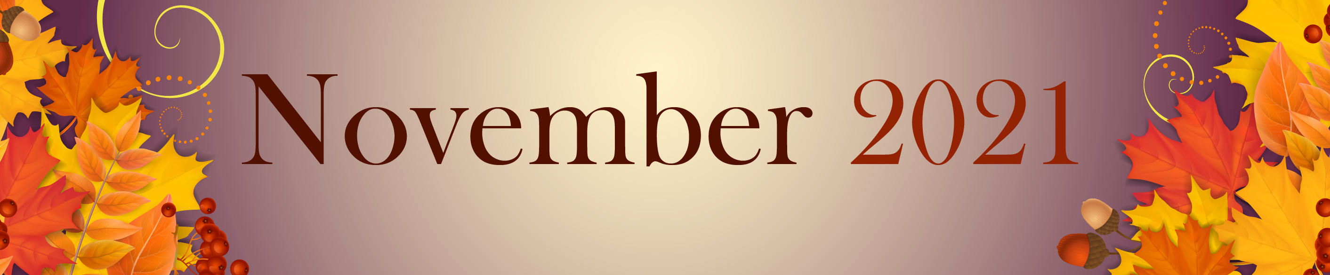

9:30 Music n Motion
2:00 Catholic Rosary
2:30 Walking Club
4:00 Sing a long

 | 1 | 2 Election Day  Beauty Shop  10:00 Catholic Mass  11:00 America Says  2:00 Rosary  2:30 Walking Club  4:00 Happy Hour | 3  10:00 Parachute Play  11:00 Picture a Word  2:00 Flu & Booster Clinic  3:00 Short story –  The Kindness Train  4:00 Rosary | 4  10:00 Basketball & Who,  What Where?  2:00 Rosary  2:30 Walking Club  4:00 Happy Hour &  Entertainment | 5  10:00 Basketball &  Can you Picture  this?  2:00 Rosary  2:30 Walking Club | 6  11:00 Morning  Movement  2:00 Rosary  2:30 Walking Club  4:00 Relaxing Music
7 Daylight Savings  10:30 Hymn Sing  1:00 Afternoon Movie  4:00 Devotion & Songs  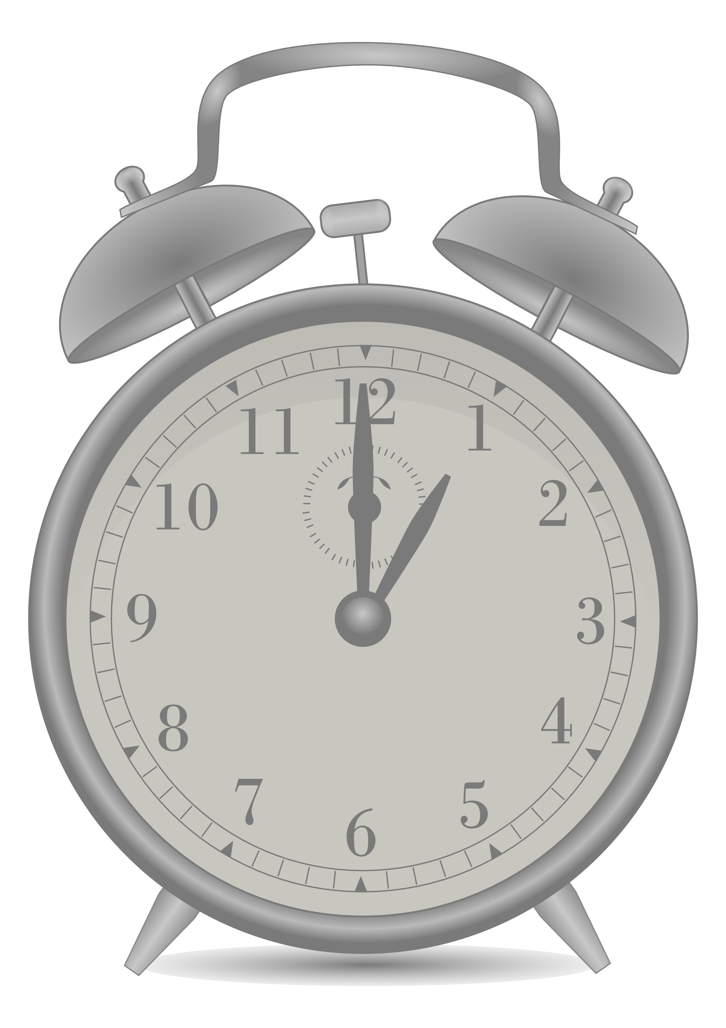 | 8  10:00 Music n’ Motion &  Rhyme Time  2:00 Rosary  2:30 Walking Club  4:00 Movie- Gone with  the Wind | 9 Beauty Shop  10:00 Bean Bag Toss  11:00 America Says  2:00 Rosary  2:30 Walking Club  4:00 Happy Hour | 10  10:00 Basketball  11:00 Junk Drawer Detective  2:00 Rosary  2:30 Walking club  4:00 Music Sing-a-long | 11 Veterans Day  10:00 Passport for  Wellness  2:00 Rosary  2:30 Walking Club  4:00 Happy Hour –  Honoring our Veterans | 12  10:00 Noodleball  1:45 Drum Circle  2:30 Walking Club  4:00 Moving Music | 13 Random Acts of  Kindness Day  11:00 Morning  Movement  2:00 Rosary  2:30 Walking Club  4:00 Relaxing  Music
14 PICKLE DAY  10:30 Hymn Sing  1:00 Afternoon Movie  4:00 Devotion & Songs | 15  10:00 Music n’ Motion &  Scategories  2:00 Rosary  2:30 Walking Club  4:00 Sing-a-Long with  Suzie Q | 16 Beauty Shop  10:00 Time for Tai Ji  11:00 Finish the Phrase  2:00 Rosary  2:30 Walking Club  4:00 Happy Craft Hour-  Sweater Pumpkins | 17  10:15 Communion Service  & Heart of the Nation  11:00 Pictionary  2:00 Rosary  2:30 Walking Club  4:00 Riddle Me This - ACTV | 18  10:00 Cardio Drumming  2:00 Rosary  2:30 Walking Club  4:00 Happy Hour | 19  10:00 Basketball  10:30 Craft Hour  2:00 Rosary  2:30 Walking Club  4:00 Classic TV | 20  11:00 Morning  Movement  2:00 Rosary  2:30 Walking Club  4:00 Relaxing Music
21  10:30 Hymn Sing  1:00 Afternoon Movie  4:00 Devotion & Songs | 22  10:00 Music n’ Motion &  Rhyme Time  2:00 Rosary  2:30 Walking Club  4:00 Travelogue –  Costa Rica | 23 Beauty Shop  10:00 Bean Bag Toss &  America Says  2:00 Rosary  4:00 Happy Hour &  Entertainment | 24  10:00 Basketball  11:00 Cranium Crunch  2:00 Rosary  2:30 Spa Day  4:00 Do You Hear What I  Hear? - ACTV | 25  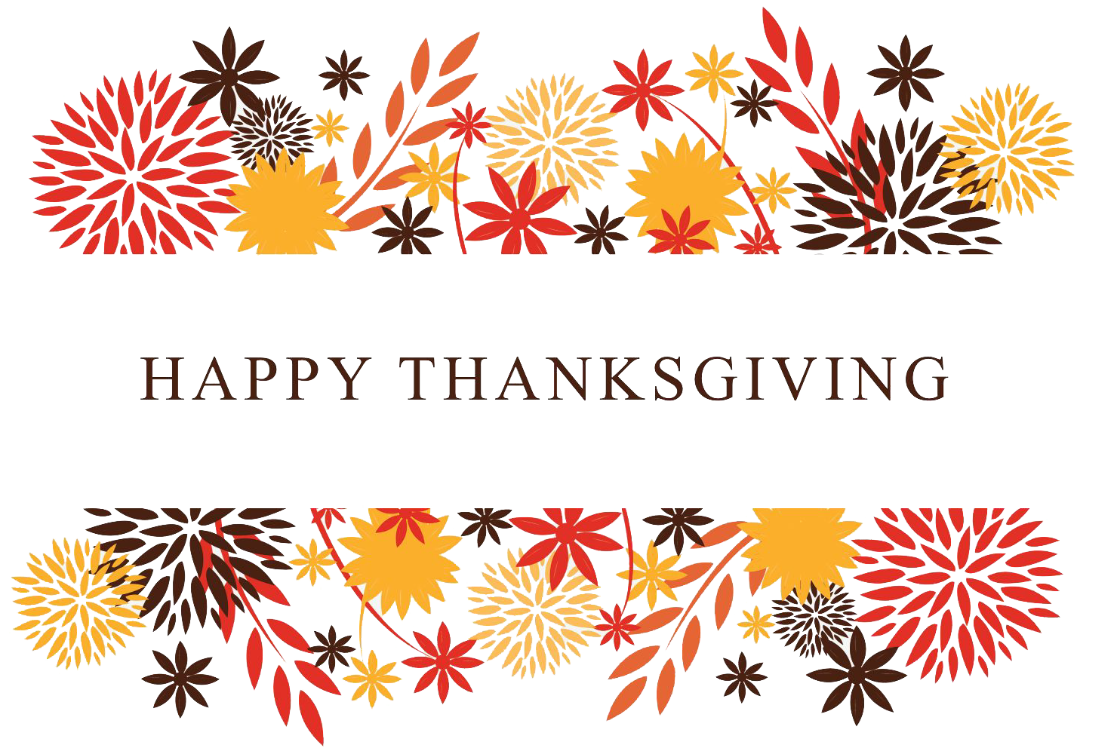 | 26  10:00 Noodleball  2:00 Rosary  2:30 Walking Club  4:00 Moving Music | 27  11:00 Morning  Movement  2:00 Rosary  2:30 Walking Club  4:00 Relaxing Music
28  10:30 Hymn Sing  1:00 Afternoon Movie  4:00 Devotion & Songs | 29  10:00 Music & Motion  2:00 Rosary  2:30 Walking Club  4:00 Horse Racing | 28 Beauty Shop  10:00 Bean Bag Toss &  Wheel of Fortune  2:00 Rosary  2:30 Walking Club  4:00 Happy Hour
SUNDAY MONDAY TUESDAY WEDNESDAY THURSDAY FRIDAY SATURDAY

