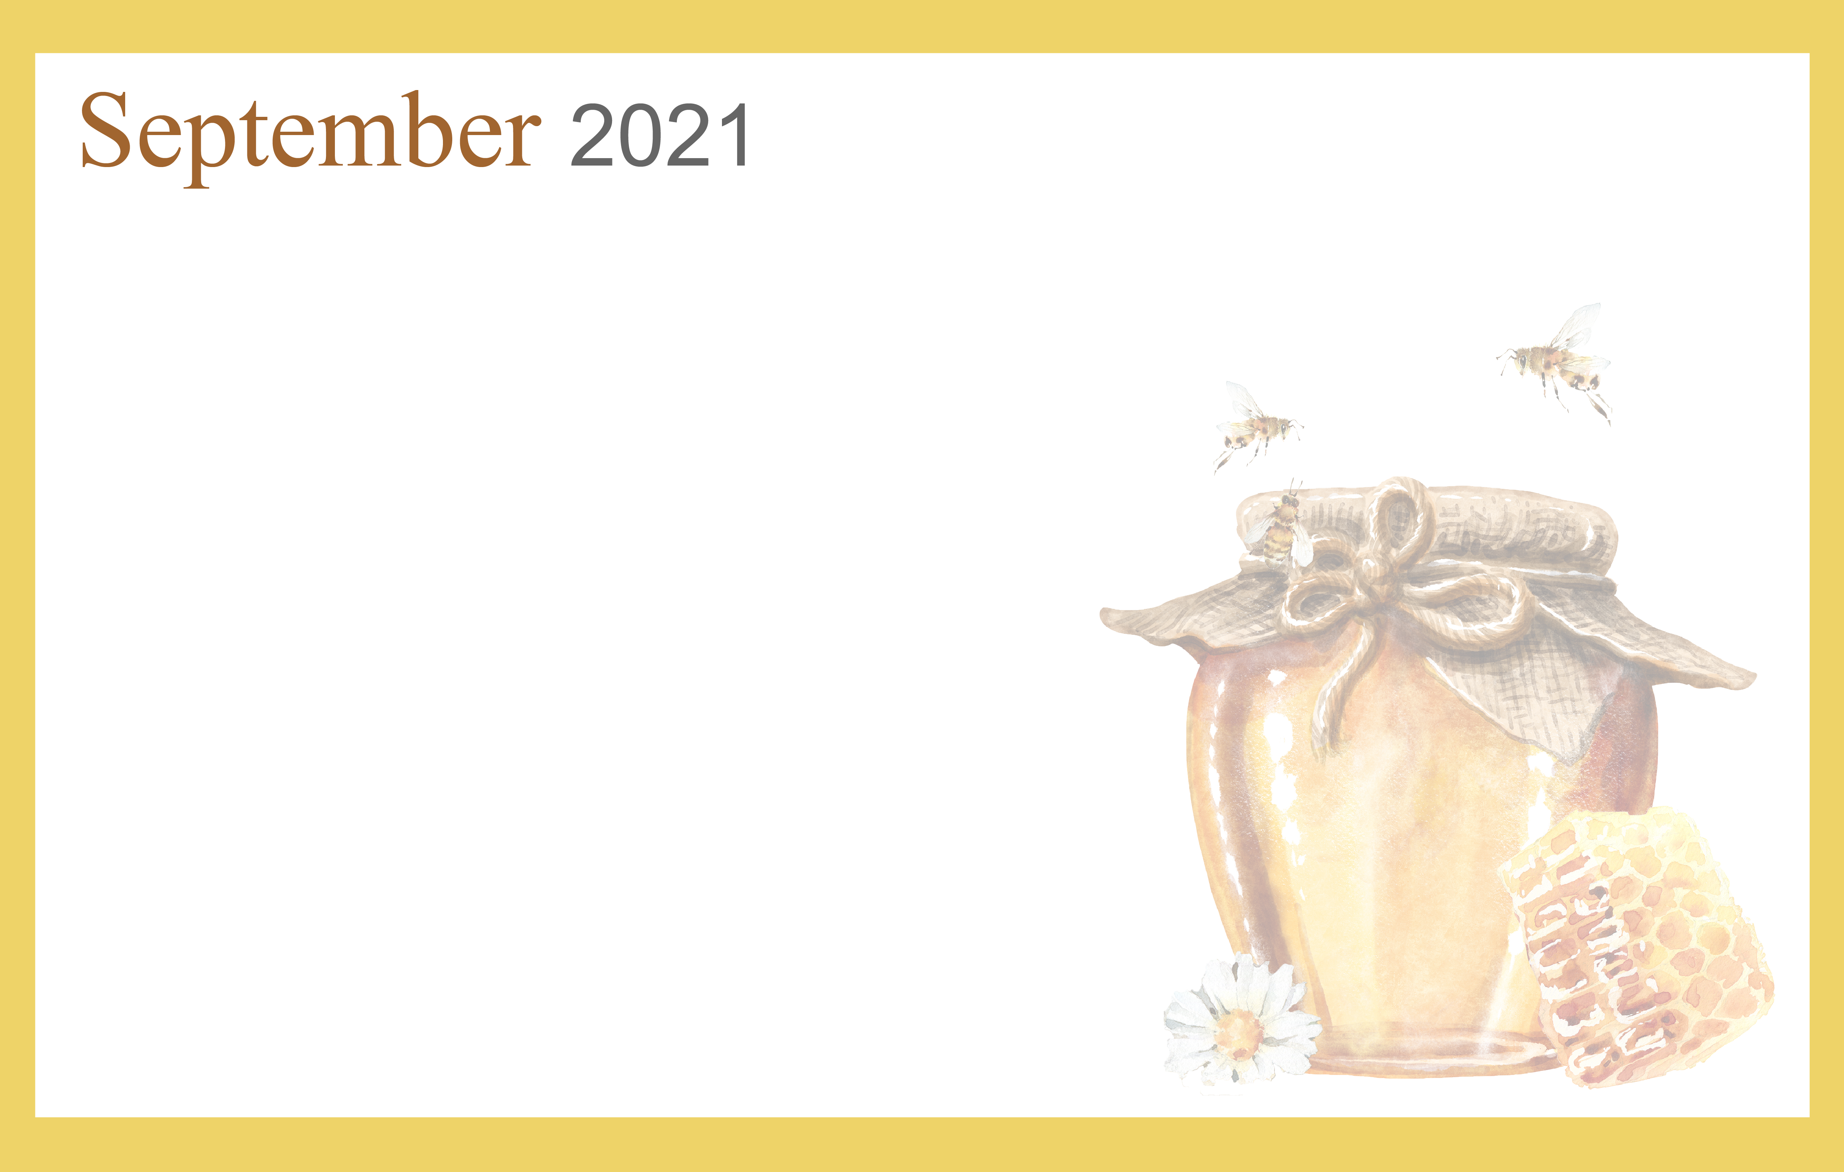
 |  |  |  | 1  10:00 Parachute Play  11:00 Olympic Matching  2:00 Rosary  2:30 Walking Club  4:00 Short story –Perfect  Day |  | 2  10:00 Basketball & Who,  What Where?  2:00 Rosary  2:30 Walking Club  4:00 Happy Hour | 3  10:00 Basketball &  Can you Picture  this?  2:00 Rosary  2:30 Walking Club | 4  11:00 Morning  Movement  2:00 Rosary  2:30 Walking Club  4:00 Relaxing Music
5  10:30 Hymn Sing  1:00 Afternoon Movie  4:00 Devotion & Songs | 6  10:00 Music n’ Motion &  Rhyme Time  2:00 Rosary  2:30 Walking Club  4:00 Book Lovers Day | 7 Beauty Shop  10:00 Catholic Mass  11:00 America Says  2:00 Rosary  2:30 Walking Club  4:00 Happy Hour | 8  10:15 Communion Service  11:00 Junk Drawer Detective  2:00 Rosary  2:30 Walking club  4:00 Music Sing-a-long |  |  | 9  10:00 Passport for  Wellness  2:00 Rosary  2:30 Walking Club  4:00 Happy Hour | 10  10:00 Tai Ji &  Dominos  2:00 Rosary  2:30 Walking Club  4:00 Moving Music | 11  11:00 Morning  Movement  2:00 Rosary  2:30 Walking Club  4:00 Relaxing Music
12  10:30 Hymn Sing  1:00 Afternoon Movie  4:00 Devotion & Songs | 13  10:00 Music n’ Motion &  Scategories  2:00 Rosary  2:30 Walking Club  4:00 Sing-a-Long with  Suzie Q | 14 Beauty Shop  9:30 Noodle YOGA  11:00 Finish the Phrase  2:00 Rosary  2:30 Walking Club  4:00 Happy Hour | 15  10:15 Communion Service  11:00 Pictionary  2:00 Rosary  2:30 Walking Club  4:00 Riddle Me This - ACTV |  |  | 16  10:00 Cardio Drumming  1:10  2:00 Rosary  2:30 Walking Club  4:00 Happy Hour | 17  10:00 Basketball  10:30 Craft Hour  2:00 Rosary  2:30 Walking Club  4:00 Classic TV | 18  11:00 Morning  Movement  2:00 Rosary  2:30 Walking Club  4:00 Relaxing Music
19  10:30 Hymn Sing  1:00 Afternoon Movie  4:00 Devotion & Songs | 20  10:00 Music n’ Motion & Rhyme Time  2:00 Rosary  2:30 Walking Club  4:00 Travelogue – | 21 Beauty Shop  10:00 Bean Bag Toss &  America Says  2:00  4:00 Happy Hour | 22  10:15 Communion Service  11:00 Cranium Crunch  2:00 Rosary  2:30 Walking Club  4:00 Do You Hear What I  Hear? - ACTV |  |  | 23  10:00 Passport for  wellness  2:00 Rosary  2:30 Walking Club  4:00 Happy Hour | 24  10:00 Basketball  2:00 Rosary  2:30 Walking Club  4:00 Moving Music | 25  11:00 Morning  Movement  2:00 Rosary  2:30 Walking Club  4:00 Relaxing Music
26  10:30 Hymn Sing  1:00 Afternoon Movie  4:00 Devotion & Songs | 27  10:00 Music & Motion  2:00 Rosary  2:30 Walking Club  4:00 Horse Racing | 28 Beauty Shop  10:00 Bean Bag Toss &  Wheel of Fortune  2:00 Rosary  2:30 Walking Club  4:00 Happy Hour | 29  10:15 Communion Service  11:00 Cranium Crunch  2:00 Rosary  2:30 Walking Club |  | 30  10:00 Cardio Drumming  1:10 Tigers Baseball  Bingo  2:00 Rosary  2:30 Walking Club  4:00 Happy Hour |  | 
SUNDAY MONDAY TUESDAY WEDNESDAY THURSDAY FRIDAY SATURDAY

