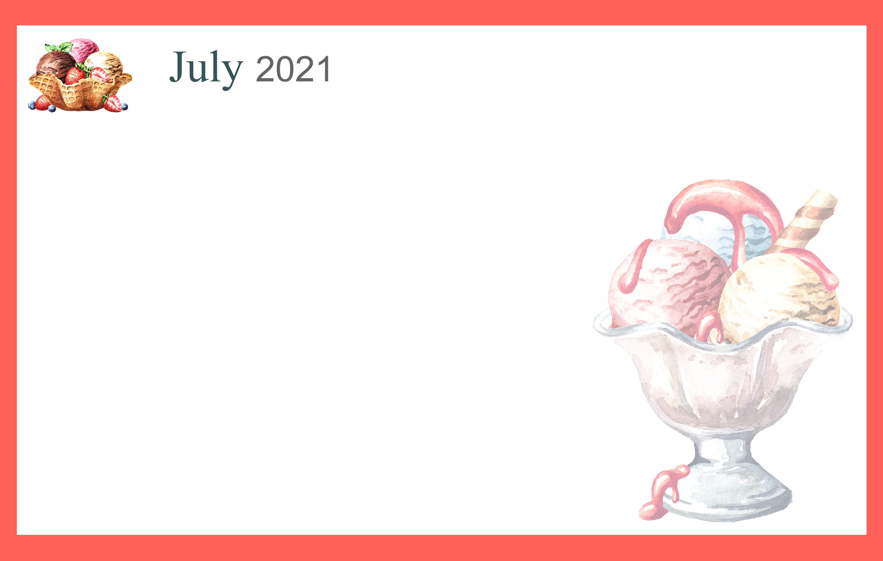

 |  |  |  | 1  10:00 Basketball & Who,  What Where?  2:00 Rosary  2:30 Walking Club  4:00 Happy Hour &  July IQ | 2  10:00 Basketball &  Can you Picture  this?  2:00 Rosary  2:30 Walking Club 4:00 EZ Random  Trivia |  | 3  10:30 Morning  Exercise  2:00 Rosary  2:30 Walking Club  4:00 Relaxing Music
4  10:30 Hymn Sing  1:00 Afternoon Movie  4:00 Devotion & Songs | 5  10:00 Music n’ Motion &  Rhyme Time  2:00 Rosary  2:30 Walking Club  4:00 A Goose of a Day | 6 Beauty Shop  10:00 Catholic Mass  2:00 Rosary  2:30 Walking Club  4:00 Happy Hour | 7 Beauty Shop  10:00 Stretch & Flex  11:00 Lucky 7 Day  2:00 Rosary  2:30 Walking club  4:00 Music Sing-a-long | 8  10:00 Passport for  Wellness  2:00 Rosary  2:30 Walking Club  4:00 Happy Hour &  Entertainment | 9  10:00 Basketball &  Dominos  2:00 Rosary  2:30 Walking Club  4:00 Moving Musc |  | 10  10:30 Morning  Exercise  2:00 Rosary  2:30 Walking Club  4:00 Relaxing Music
11  10:30 Hymn Sing  1:00 Afternoon Movie  4:00 Devotion & Songs | 12  10:00 Music n’ Motion &  Scategories  2:00 Rosary  2:30 Walking Club  4:00 Sing-a-Long with  Suzie Q | 13 Beauty Shop  9:30 Noodle YOGA  11:00 Finish the Phrase  2:00 Rosary  2:30 Walking Club  4:00 Happy Hour | 14 Beauty Shop  10:00 Parachute Play  11:00 Bastille Day  2:00 Rosary  2:30 Walking Club  4:00 Short story – Rosie the  Cyclone | 15  10:00 Cardio Drumming  Noon Cambrian Picnic  2:00 Rosary  2:30 Walking Club  4:00 Happy Hour | 16  10:00 Basketball  2:00 Rosary  2:30 Walking Club  4:00 25 Best National  Parks in the USA |  | 17  11:15 Tai Ji with  Chris  2:00 Rosary  2:30 Walking Club  4:00 Relaxing Music
18  10:30 Hymn Sing  1:00 Afternoon Movie  4:00 Devotion & Songs | 19  10:00 Music n’ Motion & Rhyme Time  2:00 Rosary  2:30 Walking Club  4:00 Travelogue – National Parks Adventure | 20 Beauty Shop  10:00 Bean Bag Toss &  America Says  2:00 Rosary  2:30 Walking Club  4:00 Happy Hour | 21 Beauty Shop  10:00 Parachute Play  11:00 Cranium Crunch  2:00 Rosary  2:30 Walking Club  4:00 National Geographic  Expeditions | 22  10:00 Passport for  wellness  2:00 Rosary  2:30 Walking Club  4:00 Happy Hour &  Entertainment | 23  10:00 Basketball  2:00 Rosary  2:30 Walking Club  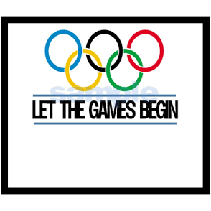 |  | 24  10:30 Morning  Exercise  2:00 Rosary  2:30 Walking Club  4:00 Relaxing Music
25  10:30 Hymn Sing  1:00 Afternoon Movie  4:00 Devotion & Songs | 26  10:00 Music & Motion  2:00 Rosary  2:30 Walking Club  4:00 Horse Racing | 27 Beauty Shop  10:00 Bean Bag Toss &  Wheel of Fortune  2:00 Rosary  2:30 Walking Club  4:00 Happy Hour | 28 Beauty Shop  10:00 Stretch & Flex  11:00 ACE Bingo  2 – 4  Outing to Crumbl Cookie Co | 29  10:00 Basketball & Who,  What Where?  2:00 Rosary  2:30 Walking Club  4:00 Happy Hour |  | 30  10:00 Basketball &  Dominos  2:00 Rosary  2:30 Walking Club  4:00 Moving Music | 31  10:30 Morning  Exercise  2:00 Rosary  2:30 Walking Club  4:00 Relaxing Music
SUNDAY MONDAY TUESDAY WEDNESDAY THURSDAY FRIDAY SATURDAY

