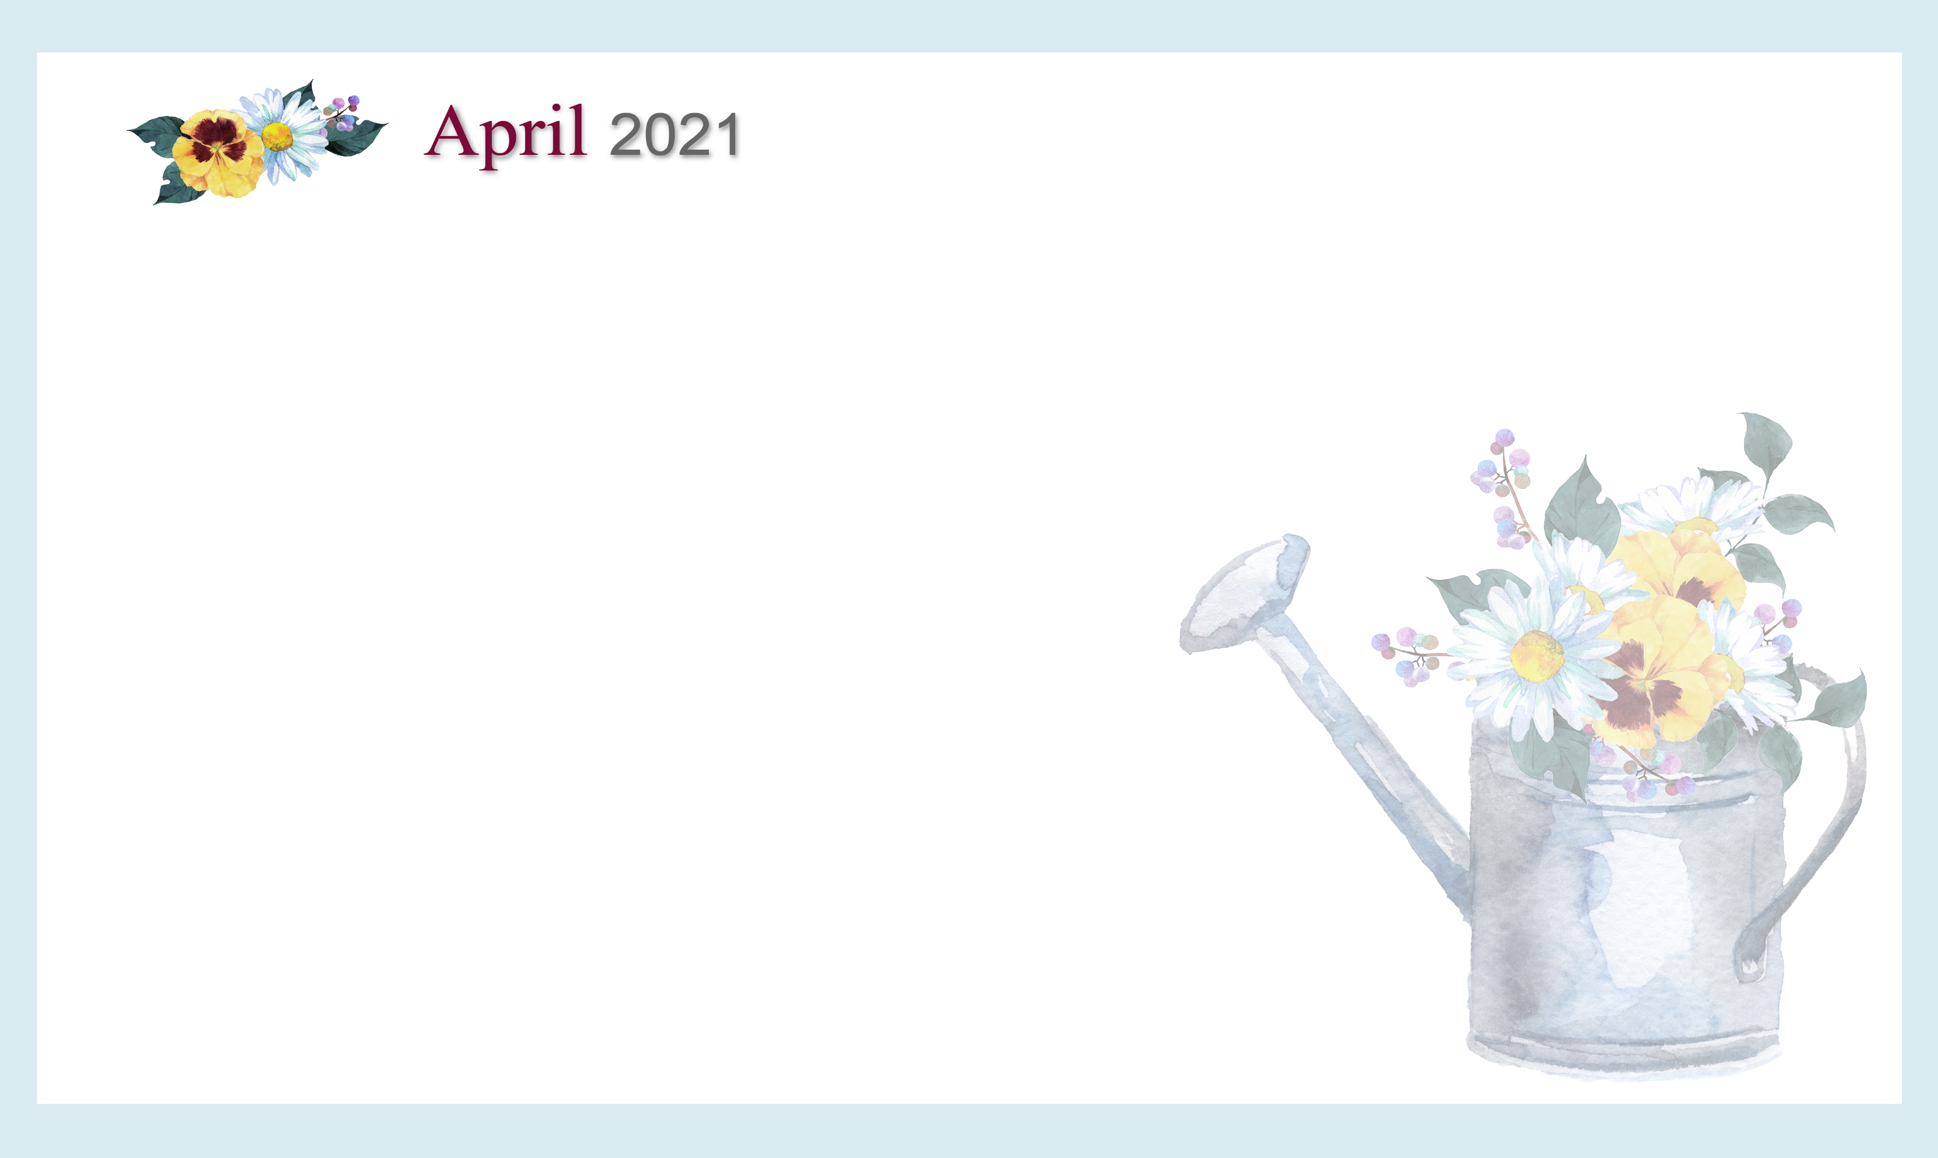

SUNDAY MONDAY TUESDAY WEDNESDAY THURSDAY FRIDAY SATURDAY

Cambrian Senior Living *52365 Ten Mile Road South Lyon, MI 48178 * [www.cambrianseniorliving.com](http://www.cambrianseniorliving.com) * Like us on Facebook

|  |  |  |  |  |  |  |  |
| --- | --- | --- | --- | --- | --- | --- | --- |
|  | | | | | **1**  **9:30** Noodle ball Sports & Picture a word  **1:00** Tiger Baseball  Opening Day  **4:00** Happy Hour | **2**    **10:00** Basketball &  Short Story: For the birds  **2:15**  Virtual Visit to the  Zoo  **4:00**  Virtual Good Friday  service | 3  10:30 Morning Exercise  2:30 Rainbow Day  4:00 Relaxing Music |
| **4**  ***Free Spiritual Easter Cliparts, Download Free Clip Art, Free Clip Art on  Clipart Library***  **10:00** Hymn Sing  **1:00** Afternoon Movie  **4:00** Devotion & Songs  9 | **5**  **10:00** Music n’ Motion &  Rhyme Time  **2:15** Color Therapy  **4:00** EZ Music | **6 Beauty Shop**  **9:30** Bean Bag Toss &  Price is Right  **2:15** Daily Chronicle  **4:00** Happy Hour | **7 Beauty Shop**  **10:00** Stretch & Flex  **10:30** Punny April  **2:15** Good day for a walk  **4:00** Singing Heart to Heart | | **8**  **9**:30 Noodle ball Sports & Junk Drawer Detective  **2:15** Puzzles &  Ponderings  **4:00** Happy Hour | **9**    **10:00** Basketball &  Can you Picture this?  **2:15** EZ Random Trivia  **4:00** Sing-a-long | **10**  10:0 Morning Exercise  2:30 Shuffleboard &  Billiards  4:00 Relaxing Music |
| **11**  **10:00** Hymn Sing  **1:00** Afternoon Movie  **4:00** Devotion & Songs | **12**  **10:00** Music n’ Motion &  Scategories  **2:15** Grilled Cheese Day  **4:00** Sing-a-Long with  Suzie Q | **13 Beauty Shop**  **10:00** Bean Bag Toss &  Wheel of Fortune  **2:15** Daily Chronicle  **4:00** Happy Hour | **14 Beauty Shop**  **10:00** Stretch & Flex  **2:15** Craft Hour  **4:00** Broadway music  Sing-a-long | | **15 – High 5 Day**  **10:00** Cardio Drumming  **2:15** Picture the Song  **4:00** Happy Hour &  McDonalds Milkshakes | **16 PJ Day!**  **10:00** Basketball  **Noon** PJ’’s. Pizza &  Movie  **2:15**  Dominos  **4:00** Moving Music | 17  11:00 Morning Exercise  2:30 Coffee &  Conversation  4:00 Relaxing Music |
| **18**    **10:00** Hymn Sing  **1:00** Afternoon Movie  **4:00** Devotion & Songs | **19**  **10:00** Music n’ Motion & Rhyme Time  **2:15** Color Therapy  **4:00** Mona Lisa Monday | **20 Beauty Shop**  **10:00** Bean Bag Toss & Movie star Danny DeVito  **2:15** Wheel of Fortune  **4:00** Happy Hour | **21 Beauty Shop**  **10:00** Stretch & Flex  Happy Birthday Queen Elizabeth – 95 yrs.  **2:15** The Meeting of Leon-artists – short story  **4:00** Blooming Botanical  Garden | | **[Related imageRelated imageRelated imageRelated image](https://www.google.com/url?sa=i&rct=j&q=&esrc=s&source=images&cd=&cad=rja&uact=8&ved=0ahUKEwiGkuir1d7WAhUE_IMKHZstCo8QjRwIBw&url=http://www.thevillagegrocer.com/seasonal/&psig=AOvVaw3aq_OxSF6RxiG0X7xiyII7&ust=1507470935230006)22**  **10:00** Noodle ball Sports & Who, What, Where?  **2:15** Picture the Song  **4:00** Happy Hour & Jelly  Bean Day | **23**  **10:00** Basketball  **2:15**  Shadow Box  Crafting  **4:00**  Courtyard  Conversation | **24**  11:00 Morning Exercise  2:30 Sense of Smell Day  4:00 Relaxing Music |
| **25**  **10:00** Hymn Sing  **1:00** Afternoon Movie  **4:00** Devotion & Songs | **26**  **10:00** Music n’ Motion  **2:15** Color Therapy  **4:00** Horse Racing | **27 Beauty Shop**  **10:00** Bean Bag Toss  **2:15** Wheel of Fortune  **4:00** Happy Hour | **28 Beauty Shop**  **10:00** Stretch & Flex  **2:15** Craft Hour  **4:00** AC Video  Charleston: Historic Tour | **29**  **10:00** Cardio Drumming  **2:15** Sensory Kits  **4:00** Happy Hour | | **30**  **10:00** Basketball  **2:15** Garden Prep  **4:00** Bingo |  |