
AL= Assisted Living  Beauty Salon & Manicures  by Appointment   |   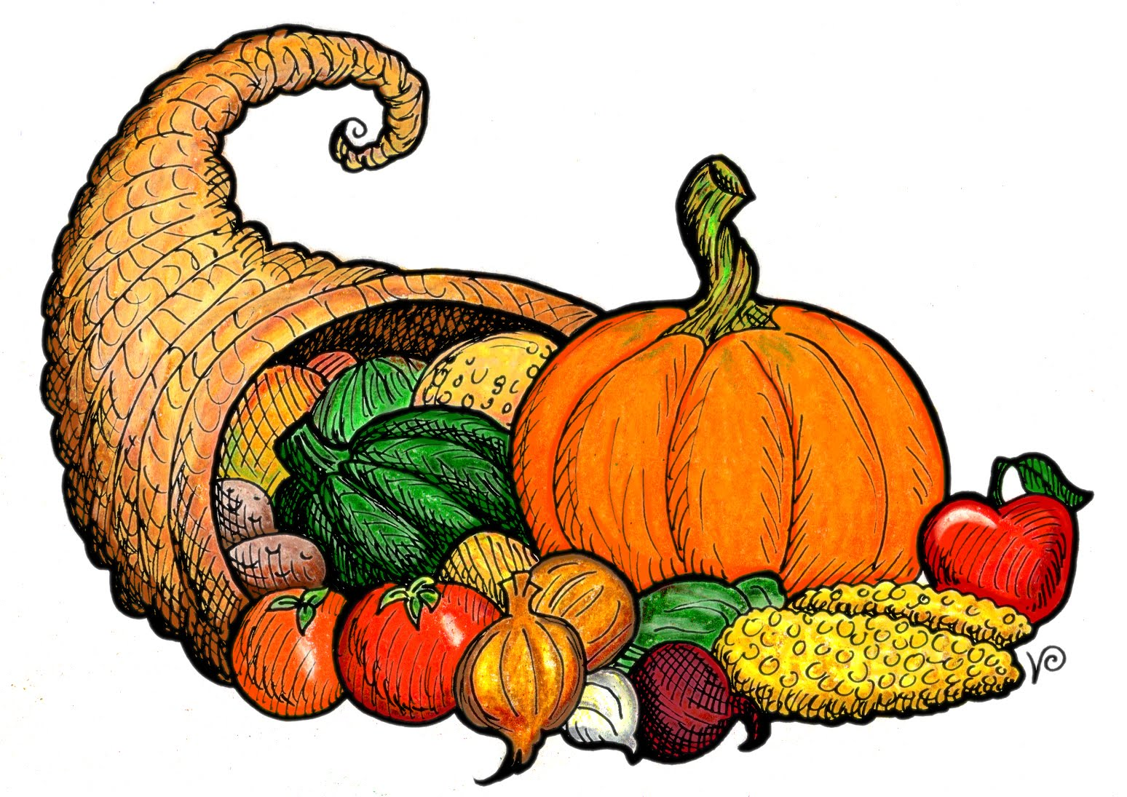 |  |  |  |  | 1  10:30 Parachute Ball  11:00 Toss Across  1:30 Worship Service (AL)  1:00 Dominoes  3:00 AGT
2 Ground Hog Day  9:30 Catholic Communion  2:00 Afternoon Relaxation  6:30 Super Bowl Sunday | 3  9:15 AM Exercise  10:00 Jokes & Riddles  1:00 Walking Club  2:15 Kitchen Club  3:00 Superbowl Celebration  6:00 Evening Music | 4 Beauty Shop  9:00 Basketball  10:00 Catholic Mass (AL)  1:00 Walking Club  2:15 Craft Hour  4:00 Happy Hour | 5  9:15 Noodle Yoga & Stretch  10:15 Bean Bag Toss  1:00 Walking Club  2:15 ACE Bingo  3:00 Snack & Conversation  6:00 Relaxing Tunes | 6  9:15 Music n’ Motion  10:00 Fill in the Word  1:00 Walking Club  2:15 Game Time  4:00 Happy Hour | 7 Fast Food Friday  9:15 Music n’ Motion  10:00 Cards  1:00 Walking Club  2:00 Drum Circle  3:00 Dotted Heart Tree  Painting  6:00 Movie & Snacks | 8  10:30 Noodle Sports  11:00 Visual Trivia  1:30 Worship Service (AL)  2:15 Bowling  3:00 Moving Art  6:15 Meditation Hour
9  9:30 Catholic Communion  1:00 Matinee Movie  3:00 Afternoon Tunes | 10  9:15 Stretch & Flex  10:00 Name that Tune  1:00 Walking Club  2:15 Nutella Fudge Activity  3:00 Snack & Short Story  6:00 Peaceful Piano Music | 11 Beauty Shop  9:15 Balloon Volleyball  10:00 Fill in the Word  1:00 Walking Club  2:15 Reminiscing with the  Senses  4:00 Happy Hour | 12  9:15 Hymn Sing  10:00 Lunch Outing  10:15 Catholic Communion(AL)  1:00 Walking Club  2:15 Dice Games  3:00 Snack & Music  6:00 Evening Mediation | 13  9:15 Passport to Wellness  10:30 Sing-a-Long  1:00 Walking Club  3:00 Valentine’s Day  Detective  4:00 Happy Hour | 14 Valentine’s Day  9:15 Exercise Ball  10:30 Valentine’s Day  Celebration  2:15 Valentine’s Day  Puzzles    3:30 ABC Sisters Singing Group Performance | 15  10:30 Morning Movement  11:00 ACE Bingo  1:30 Worship Service (AL)  2:00 Horse Racing  3:00 YouTube It!  6:00 Evening Relaxation
16  9:30 Catholic  Communion  2:00 Family Classics  6:00 Evening Mediation | 17  9:15 Noodle Yoga  10:00 President’s Day  1:00 Walking Club  2:15 Card Games  3:00 Snack & Would You  Rather?  6:15 Relaxing Aquarium | 18 Beauty Shop  9:00 Cardio Drumming  10:00 Trivia  1:00 Walking Club  2:15 Sensory Science  Experiment    4:00 Happy Hour &  Entertainment | 19 First Day Of Spring  9:15 Music n’ Motion  10:15 Catholic Communion(AL)  11:00 Worship w/ Jo  1:30 Corn Flake Day  3:00 Snack & Discussion  6:30 Calming Music | 20  9:15 Parachute Ball  10:00 Brain Games  1:00 Walking Club  2:15 Brown Paper Bag Day  4:00 Happy Hour | 21 National Caregiver’s Day  9:15 Basketball  10:00 Family Feud  2:15 Out & About  3:00 Matinee Movie  6:00 Oldies Music | 22  10:30 Noodle Sports  11:00 Card Games  1:30 Worship Service (AL)  2:15 Can You Picture This?  3:00 Safari Wildlife  6:15 Mediation Hour
23  9:30 Catholic Communion  1:00 Walking Club  4:00 Color Therapy | 24  9:15 Passport to Wellness  10:15 Sweet Stories  1:00 Walking Club  2:15 Bingo  3:00 Snack & Short Story  6:00 Moving Art | 25 Beauty Shop  9:15 AM Exercise    10:00 Can You Picture This?  1:30 Bowling  3:00 Sing-along w/ Mark(AL)  4:00 Mardi Gras Happy Hour | 26 Ash Wednesday  9:00 Hymn Sing  10:15 Catholic Communion(AL)  10:30 Dice Games  1:00 Walking Club  2:15 Pistachio Day  3:00 Snack & Mad Libs  6:15 Nighttime Tunes | 27  9:15 Morning Music  10:00 BINGO  1:00 Walking Club  3:00 Blooming Flowers  4:00 Happy Hour | 28  9:00 Let’s Dance!  11:00 Laughter Club  1:00 Walking Club  2:15 Flap Jack Friday  3:00 Movie & Snacks  6:30 Nature Time-lapse |   29 Leap Day  10:30 Moring Movement  11:00 Leaping into  February Trivia  1:30 Worship Service  2:15 Dominoes  3:00 Afternoon Music  6:00 Rest & Relaxation
SUNDAY MONDAY TUESDAY WEDNESDAY THURSDAY FRIDAY SATURDAY
Cambrian Senior Living *52365 10 Mile Rd. * South Lyon, MI 48178 * www.cambrianseniorliving.com * Like us on Facebook

