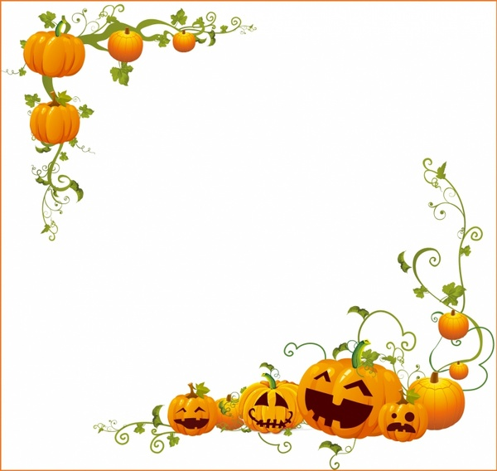mikujkujkk,`

|  |  |  |  |  |  |  |
| --- | --- | --- | --- | --- | --- | --- |
| See the source imageSee the source image | See the source imageSee the source image | **1**  10:00 Catholic Mass (AL)  10:30 UNO  2:15 **Homemade Cookie Day**  4:00 Happy Hour | 2  9:15 Parachute Ball  10:00 Brain Games  2:15 Bird Bingo  3:00 Snack & Game  6:00 Lawrence Welk Show | **3**  9:15 Basketball  11:00 Trivia  2:15 Craft Time  4:00 Happy Hour | **4**  9:15 Music n’ Motion  10:00 Dominoes  2:15 **Taco Day**  3:00 Matinee Movie  6:15 Nature Timelapse | **5**  10:00 Bingo!  1:30 Worship Service (AL)  2:15 Movie & Snack  6:15 Evening Mediation |
| **6**  9:30 Catholic Communion  1:00 Music & Mandalas  3:00 Family Classics  6:30 Rest & Relaxation | **7**  10:30 **Meet & Greet w/ Tricia**  2:15 Game Time  3:00 Dick Van Dyke  6:00 Meditation Music | **8 Beauty Shop**  9:15 Passport to Wellness  10:00 Sing-a-long  2:15 Bowling  4:00 Happy Hour | **9** **Beauty Shop**  9:15 Hymn Sing  10:15 Catholic Communion(AL)  11:00 Noodle Yoga  2:15 **Beer & Pizza Day**  3:00 Snack & Conversation  6:00 Green Acres | **10**  9:15 Exercise Ball  10:00 Apple Orchard Outing  2:15 Horse Racing  4:00 Happy Hour | **11**  9:15 Stretch & Flex  10:00 **Weems Day**  2:00 Drum Circle  3:00 Matinee Movie  6:00 Blooming Flowers | **12**  10:30 Song & Dance  11:00 Would You Rather?  1:30 Lutheran Worship (AL)  2:15 A Batty Day  3:00 Oldies Music  6:30 Evening Relaxation |
| **13**  9:30 Catholic Communion  11:00 Music Therapy  2:30 Aqua Art  6:00 Netflix Movie | **14**  10:30 AM Exercise  11:00 Reminisce Stories  2:15 Card Games  3:00 YouTube It!  6:15 Relaxing Aquarium | **15 Beauty Shop**  9:15 Noodle Sports  10:00 Name Game  2:15 Bean Bag Toss  4:00 Happy Hour  6:00 **“I Love Lucy” Premiere Anniversary** | **16 Beauty Shop**  9:15 Morning Music  10:15 Catholic Communion(AL)  11:00 Worship w/ Jo  2:15 Craft Hour  3:00 Snack & Short Stories  6:15 Strange Animals of Asia | **17**  9:15 Music n’ Motion  10:00 Dictionary Game  2:15 Dominoes  4:00 Happy Hour | **18**  9:15 Noodle Yoga  10:30 Lunch Outing  2:15 Rest & Relaxation  3:00 Matinee Movie  6:15 National Geographic | **19**  10:30 Parachute Ball  11:00 ACE Bingo  1:30 Lutheran Worship (AL)  2:15 Game Time  3:00 **Hocus Pocus Holiday**  6:15 Mediation Hour |
| **20**  9:30 Catholic  Communion  11:00 Color Therapy  2:00 Mediation Music  6:00 Turner Classic Movie | **21**  10:30 Morning Exercise  11:00 Junk Drawer Detective  2:15 Bird Bingo  3:00 Andy Griffith Show  6:30 Peaceful Piano | **22 Beauty Shop**  9:15 Basketball  10:00 Can You Picture This?  2:15 Dice  4:00 Happy Hour | **23**  9:15 Hymn Sing  10:15 Catholic Communion(AL)  10:30 Horse Racing  2:15 Eatin’ Pumpkin Day  3:00 Snack & AGT  6:15 Life Under the Sea | **24 Beauty Shop**  9:15Thursday Tunes  10:00 Out & About  2:15 Toss Across  4:00 Happy Hour | **25**  9:15 Passport to Wellness  10:00 Card Games  2:15 Pumpkin Carving  3:00 Matinee Movie  6:00 Colors of Nature | **26**  10:30 Stretch & Flex  11:00 Trivia  1:30 Lutheran Worship (AL)  1:00 Trick-or-Treat  3:00 Sing-a-long  6:00 Evening Music |
| **27**  9:30 Catholic Communion  10:30 Morning Music  3:00 Aqua Art  6:15 Rest & Relaxation | **28**  10:00 AM Exercise  11:00 Story Time  2:15 UNO  3:00 Monday Musical  6:00 Beautiful Butterflies | 29  **9:15 Exercise Ball**  **10:00 National Cat Day**  2:15 Dominoes  4:00 Happy Hour | **30**  Cambrian Senior Living *52365 10 Mile Rd. * South Lyon, MI 48178 * [www.cambrianseniorliving.com](http://www.cambrianseniorliving.com) * Like us on Facebook  9:15 Morning Stretch  10:15 Catholic Communion(AL)  2:15 **Candy Corn Day**  3:00 Snack & Tunes  6:00 Camouflage Animals | **31**  9:15 Noodle Sports  10:00 Pumpkin Bowling  1:00 Halloween Party  4:00 Happy Hour  Image result for happy halloween clipart |  | MemoryCare logo |

**SUNDAY** **MONDAY** **TUESDAY** **WEDNESDA**Y **THURSDAY** **FRIDAY** **SATURDAY**